**ONLINE MOVIE TICKET BOOKING SYSTEM**

**PRESENTED BY:**

**RA2211003010192(KARTHIKEYA DEVARLA)**

**RA2211003010169(KOMMEPALLI GOWTHAM REDDY)**

**RA2211003010154(SIDDARTH JAVVADI)**

**SECTION:**C1

1)CUSTOMER SQL COMMANDS:

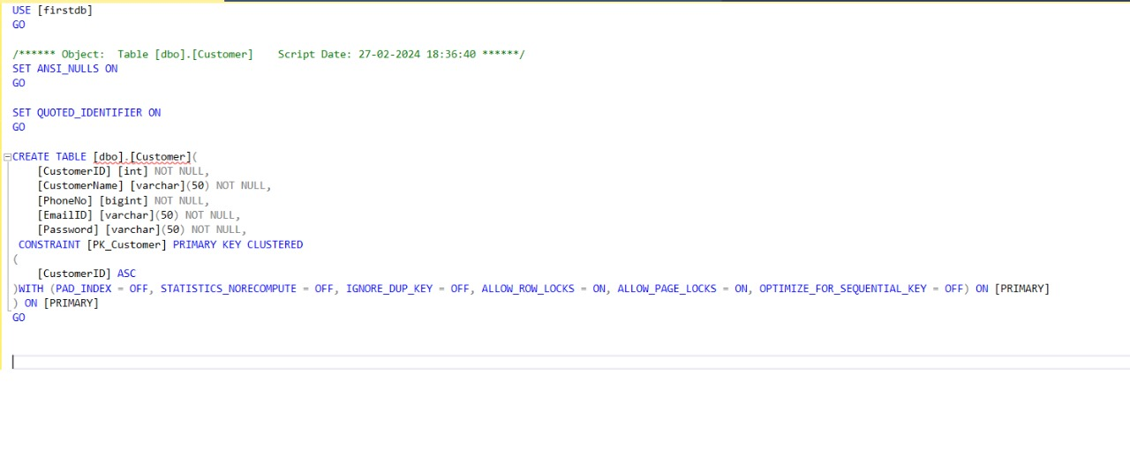

CUSTOMER TABLE:  
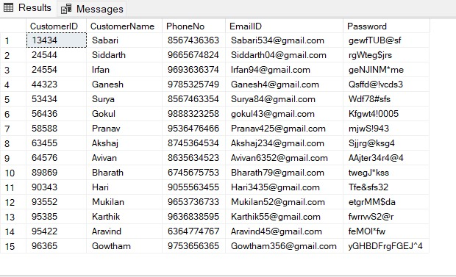

2)ADMIN SQL COMMANDS:

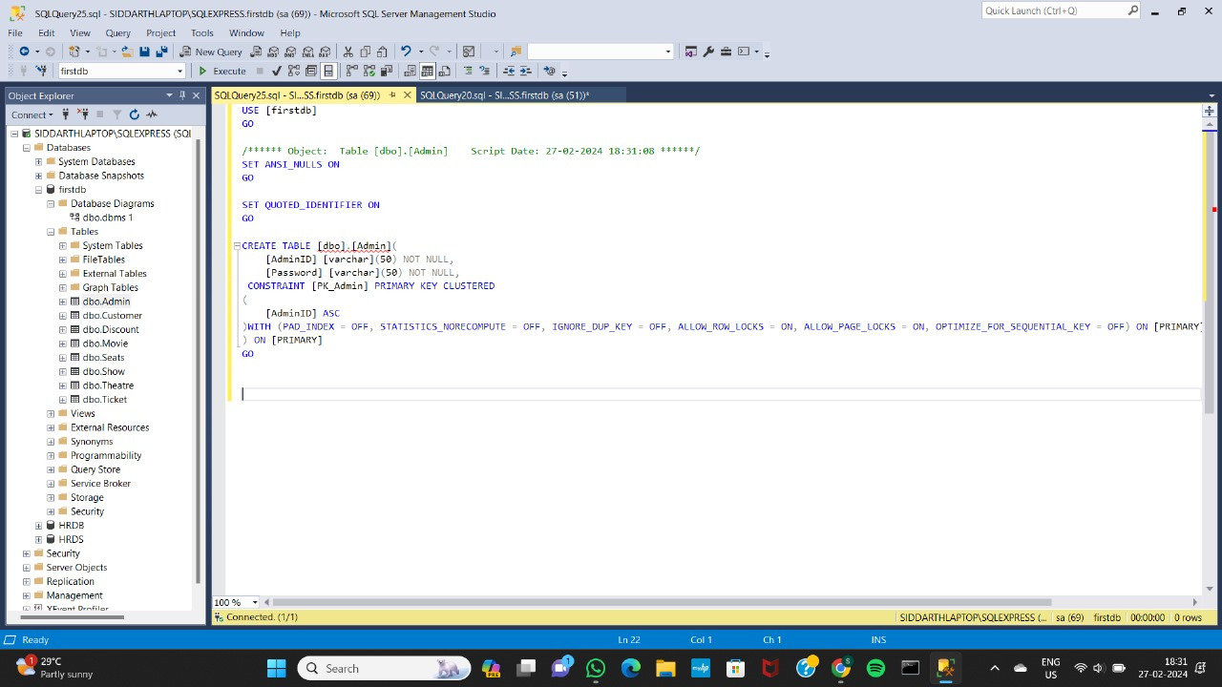

ADMIN TABLE:

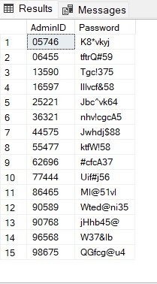

3)DISCOUNT SQL COMMANDS:

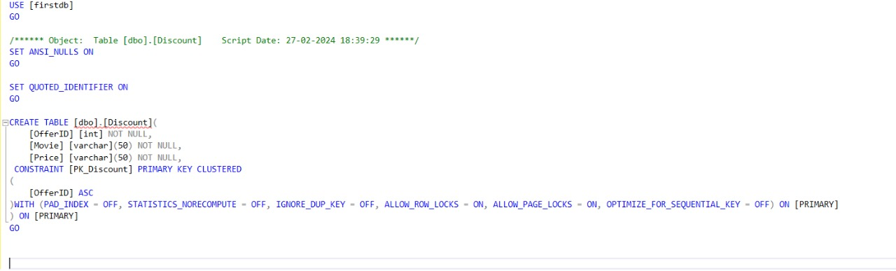

DISCOUNT TABLE:

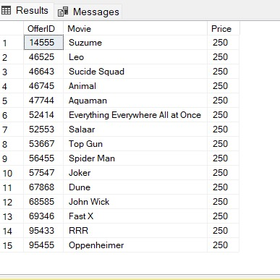

4)MOVIE SQL COMMANDS:

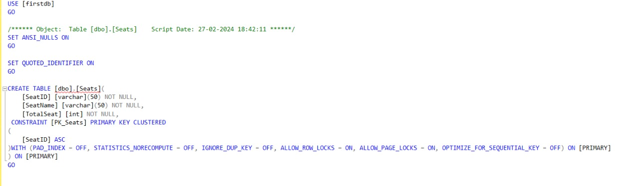

MOVIE TABLE:

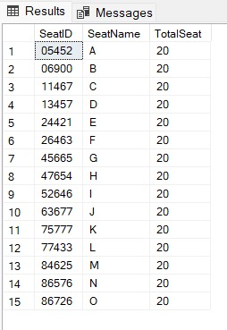

5)SEAT SQL COMMANDS:



SEAT TABLE

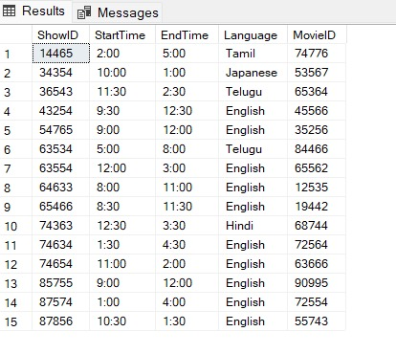

6)SHOW SQL COMMANDS:

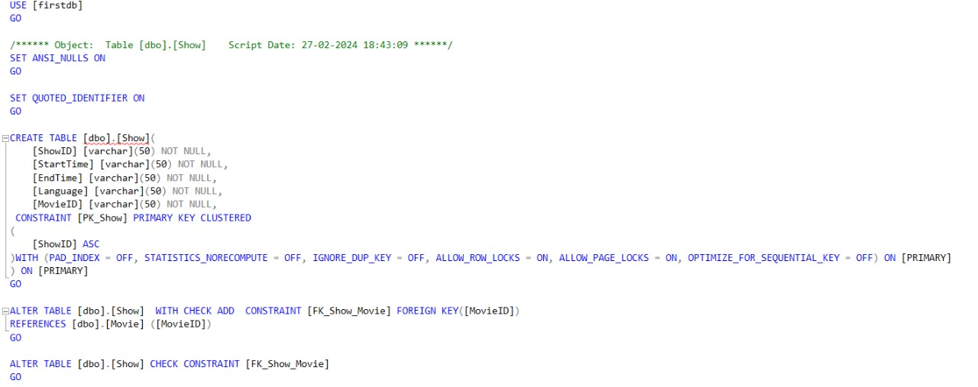

SHOW TABLE:



7)THEATRE SQL COMMANDS:

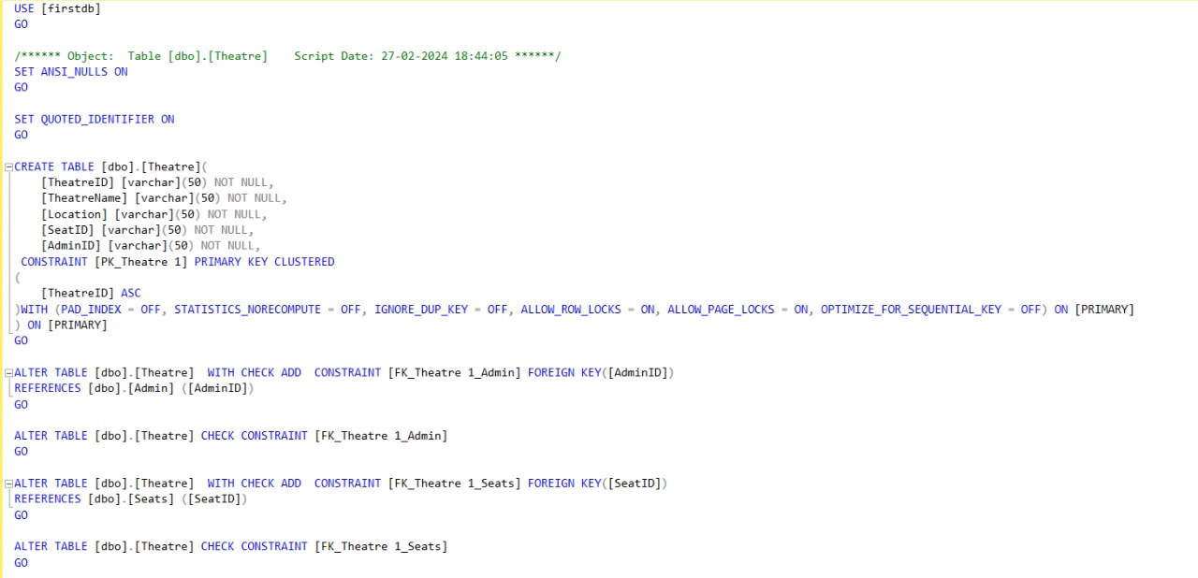

THEATRE TABLE:

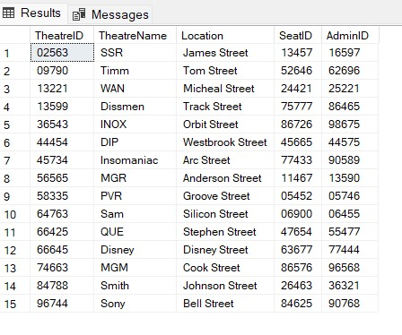

8)TICKET SQL COMMANDS:

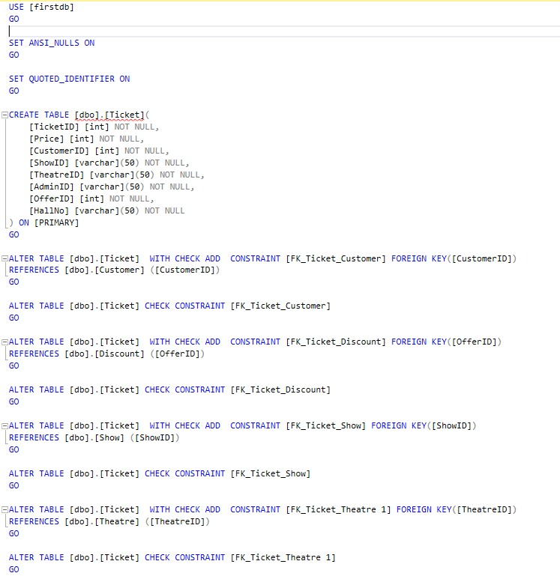

TICKET TABLE:

